# Appendix: Room states, paths, and player choice

Starter sub: Room 2 is at HighFlood and Room 3 is on fire. The player starts their turn in Room 2.

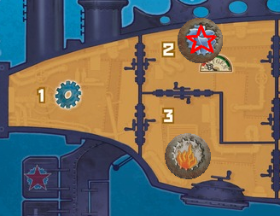

If the player wants to move to Room 1, they have two options. The first is to open the hatch to Room 3, flooding that room and putting out the fire, then opening the hatch to Room 1 and moving through it.

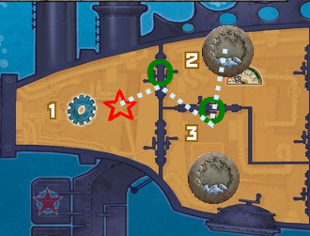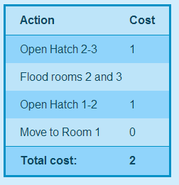

Alternately, the player can open the hatch to Room 1 first, flooding Room 1. When the player moves into Room 1, it costs 1 minute instead of 0 because the room is now flooded.

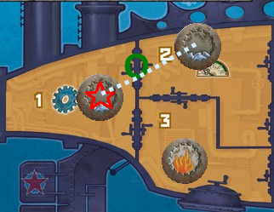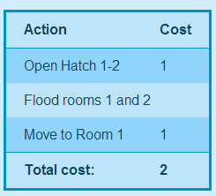

These two options have the same total cost, even though the first one opened a “useless” hatch. In addition, the first option has extinguished a fire on the ship, so the player may want to choose the first option instead of the second.